Decoding Caller-ID Signaling with the Scenix SX Micro-controller

Chris Fogelklou
Applications Engineer
Scenix Semiconductor, Inc.
Introduction
This document describes the source code CID_3_00.src.
In the past, such telephony functions as FSK (frequency-shift keying) generation and detection, DTMF (dual-tone, multi-frequency) generation and detection, and Caller ID could not be implemented with an 8-bit embedded MCU because performance levels were not high enough to support them. As a result, either a custom MCU had to be designed or a 16- or 32-bit device used. Now, the 8-bit Scenix Semiconductor SX Series MCUs, which have performance reaching 100 MIPS (million instructions per second) and a deterministic interrupt architecture, overcome this roadblock by providing the ability to perform these functions in software.
Unlike other MCUs that add functions in the form of additional silicon, the SX Series uses its industry-leading performance to execute functions as software modules, or Virtual Peripherals. These are loaded into a high-speed (10 ns access time) on-chip flash/EEPROM program memory and executed as required. In addition, a set of on-chip hardware peripherals is available to perform operations that cannot readily be done in software, such as timers, comparators, and oscillators.
Caller-ID is a method of providing telephone users with a way of knowing from whom an incoming call originates. It is a signal which is broadcast as the phone begins to ring (It is sent before the first ring in Europe and between the first and second rings in North America.) A Caller-ID box receives the incoming Caller-ID data, stores it, and outputs the caller's name and number on a display.
Caller-ID is transmitted as an FSK signal. FSK is a form of modulation used to transmit digital data over analog telephone lines. FSK stands for Frequency Shift Keying, and it uses frequency- shifts to transmit data. Since binary data is stored as '1's and '0's, there are two frequencies used for Frequency Shift Keying; one frequency symbolizes high data, and the other frequency symbolizes low data. A transmitted signal is modulated by a bitstream of 1200bps, with the frequency of the sine wave alternating as the data bits are modulated onto the carrier.
The Solution
The Caller-ID solution was originally designed to run on the Scenix DTMF Demonstration board, and has now been ported to run on the Scenix Modem Demonstration board, or V.23 Evaluation Kit. The V.23 Evaluation kit is designed to support DTMF Generation and Detection, FSK Generation and Detection, and Caller-ID Detection. The board hardware includes discrete components to enable D/A and A/D conversion, hybrid circuitry, low-pass and high-pass filtering and zero-cross signal detection.
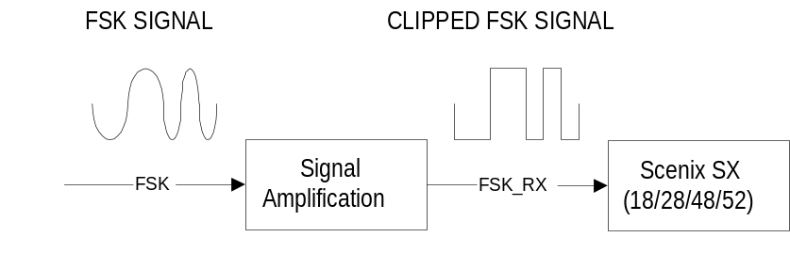The Hardware
A simple block diagram of the hardware required for a Caller-ID detection circuit with the SX:

Looking at the Circuit Diagram in Appendix B: Schematics of the Scenix Modem Demonstration Board, the blocks of the hardware that would be implemented in a commercial Caller-ID solution are:
-B5) On-Hook Snoop Circuitry
-B6) Gain Stage
-B7) Zero-Cross Comparator
These are the I/O pins used for Caller-ID
rx_pin = ra.1 ; RS-232 reception pin
tx_pin = ra.2 ; RS-232 transmission pin
led_pin = rb.0 ; LED pin... Flashes an LED while program is running.
hook = rb.4 ; drive hook low to go off-hook
rts = rb.6 ; indicates to the SX that the PC wants to transmit
; data (hardware flow control)
cts = rb.7 ; indicates to the PC that the SX is ready to
; receive data ( " " ")
fsk input = rb.1 ; FSK input (zero-cross) on RB.1

Coupling the SX with an external LCD and EEPROM would create a complete Caller-ID solution. A complete answering machine with Caller-ID can be created with the addition of DTMF detection Virtual PeripheralTM and a voice recording/playback IC.

The Firmware:
Virtual PeripheralsTM included with the Caller-ID software.
- FSK receive (V.23 Frequencies of 1300Hz for a '1' and 2100Hz for a '0') @1200bps, 7 data bits, 1 stop bit.
- 62-byte buffer
- RS-232 receiver @ 9600bps, 8 data bits,1 stop bit, and Hardware Flow Control.
- RS-232 transmitter @ 9600bps, 8 data bits,1 stop bit, and Hardware Flow Control.
- 5ms timer

All of these Virtual Peripherals run in an Interrupt Service Routine with an interrupt rate of 306.7kHz. Each pass of the interrupt service routine runs one of seven "threads." Each of the threads can run at a factor-of-2 divide down of the actual interrupt rate. Brief descriptions of each component of each Virtual Peripheral, and its actual sampling rate follow:
FSK Receive:
- fskZeroCrossTimer: Zero-Cross timer for FSK detection: Counts time between transitions on FSK input pin. Sample rate = (306.7kHz / 4)
- fskRxProc1: Removes some of the jitter away from the low frequency detection algorithm by continuously checking the transition count to see if it has now reached a point where it is safe to say that there is no high frequency present. Sets fskRxBit if low frequency is detected. Sample rate = (306.7kHz / 8)
- fskRxProc2: Runs only when a transition has occurred on the FSK input pin. It adds the last transition count to the current one and checks this against the high/low frequency threshold. If the transition count is below the threshold, the fskRxBit flag is cleared. Sample rate = (306.7kHz/8)
- fskReceive: Asynchronous 1200bps/N/7/1 receiver for retrieving bytes of data from the FSK demodulator. Sample rate = (306.7kHz/8)

5ms Timer:

- Increments a counter every 5ms and sets the timer_flag when the counter rolls over to zero. Also flashes the LED pin. Sample rate = (306.7kHz/8)

RS-232 Transmitter:

- Outputs data on tx_pin at 9600bps/N/8/1. Sample rate = (306.7kHz/8)

RS-232 Receiver:

- Receives data on rx_pin at 9600bps/N/8/1. Sample rate = (306.7kHz/8)

APPENDIX A: The Interrupt Service Routine Block Diagram
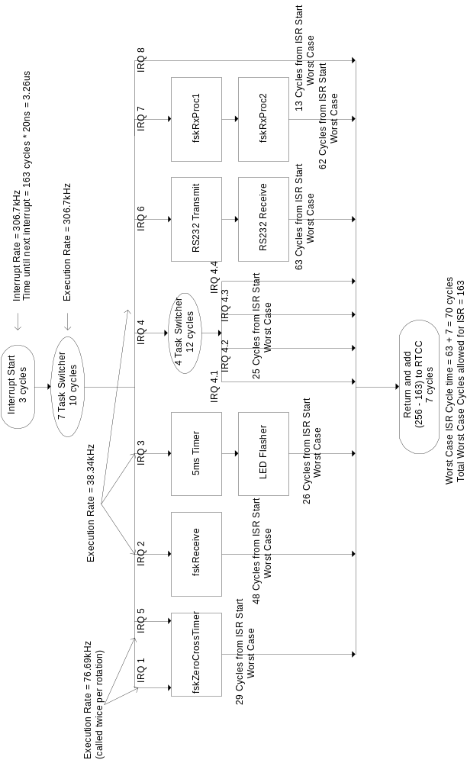

APPENDIX B: Schematics of the SX Modem Demo Board, Rev 1.2

